# School of Engineering at Penn State Behrend

Ranked among the [top 50 undergraduate engineering programs(link is external)](http://colleges.usnews.rankingsandreviews.com/best-colleges/rankings/engineering) in the country by*U.S. News & World Report*, the School of Engineering offers both [engineering and engineering technology](https://psbehrend.psu.edu/school-of-engineering/resources-for/prospective-students-1/engineering-or-engineering-technology) programs to accommodate diverse learning styles and career goals. Small class sizes allow students to work closely with faculty, while design and [research projects](https://psbehrend.psu.edu/school-of-engineering/research-outreach), internships and co-ops provide practical engineering experience. A unique partnership with the college’s Sam and Irene Black School of Business creates [multidisciplinary learning experiences(link is external)](http://behrend.psu.edu/academic/business/degrees/ibe/index.htm) valued by employers. In fact, more than 95 percent of our graduates are employed in their field within a year of graduation.

# Academic Programs

## Bachelor's Degrees

* [Computer Engineering](https://psbehrend.psu.edu/school-of-engineering/academic-programs/computer-engineering)
* [Computer Science](https://psbehrend.psu.edu/school-of-engineering/academic-programs/computer-science)
* [Electrical Engineering](https://psbehrend.psu.edu/school-of-engineering/academic-programs/electrical-engineering)
* [Electrical & Computer Engineering Technology](https://psbehrend.psu.edu/school-of-engineering/academic-programs/electrical-computer-engineering-technology)
* [Interdisciplinary Business with Engineering Studies](https://psbehrend.psu.edu/node/7272)
* [Industrial Engineering](https://psbehrend.psu.edu/school-of-engineering/academic-programs/industrial-engineering)
* [Mechanical Engineering](https://psbehrend.psu.edu/school-of-engineering/academic-programs/mechanical-engineering)
* [Mechanical Engineering Technology](https://psbehrend.psu.edu/school-of-engineering/academic-programs/mechanical-engineering-technology)
* [Plastics Engineering Technology](https://psbehrend.psu.edu/school-of-engineering/academic-programs/plastics-engineering-technology)
* [Software Engineering](https://psbehrend.psu.edu/school-of-engineering/academic-programs/software-engineering)

## Master's Degree

* [Master of Manufacturing Management](https://psbehrend.psu.edu/node/8179)

## Associate Degrees

* [Electrical Engineering Technology](https://psbehrend.psu.edu/school-of-engineering/academic-programs/electrical-computer-engineering-technology/curriculum/curriculum-eet-associate)
* [Mechanical Engineering Technology](https://psbehrend.psu.edu/school-of-engineering/academic-programs/mechanical-engineering-technology/curriculum/curriculum-MET-associate)

## Minors

* [Computer Engineering](https://psbehrend.psu.edu/node/6431)
* [Computer Science](https://psbehrend.psu.edu/node/6450)
* [Game Development](https://psbehrend.psu.edu/school-of-engineering/academic-programs/computer-science/curriculum/game-development-minor)

## Certificates

* [Electrical Engineering Technology Certificates](https://psbehrend.psu.edu/school-of-engineering/academic-programs/certificate-programs/eet-certificates)
* [Game Development Certificates](https://psbehrend.psu.edu/school-of-engineering/academic-programs/certificate-programs/game-development-certificates)
* [Mechanical Engineering Technology Certificates](https://psbehrend.psu.edu/school-of-engineering/academic-programs/certificate-programs/mechanical-engineering-technology-certificates)
* [Medical Plastics Certificate](https://psbehrend.psu.edu/school-of-engineering/academic-programs/certificate-programs/medical-plastics-certificate)
* [Plastics Processing Certificate](http://psbehrend.psu.edu/school-of-engineering/academic-programs/certificate-programs/plastics-processing-certificate)



[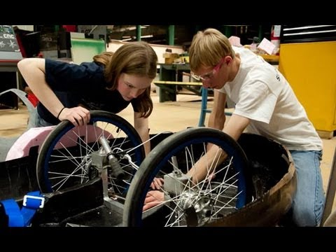](https://www.youtube.com/watch?v=nPQ2_cm1oAc)